**Working with Remote git**

* Scenario: We will be simulating two developers working on git 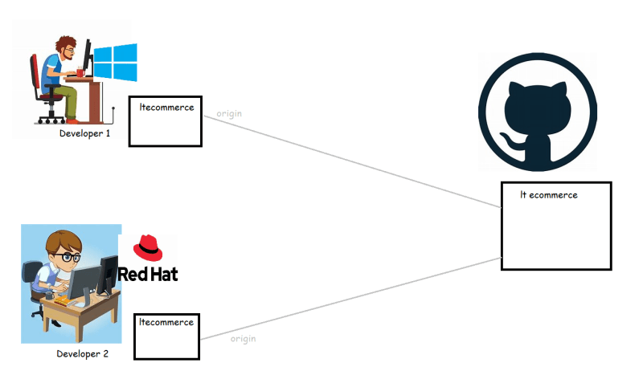

Configure username and email for the git users in linux and windows

* git config --global user.name "your-username"
* git config --global user.email "your-email"

On the linux machine lets use ssh to connect to git, for that we need to configure ssh keys in the remote repository

create ssh-key pair > ssh-keygen

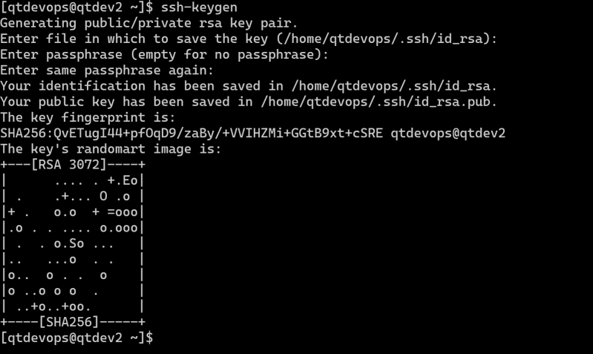

Copy the public ssh-key to github ssh keys

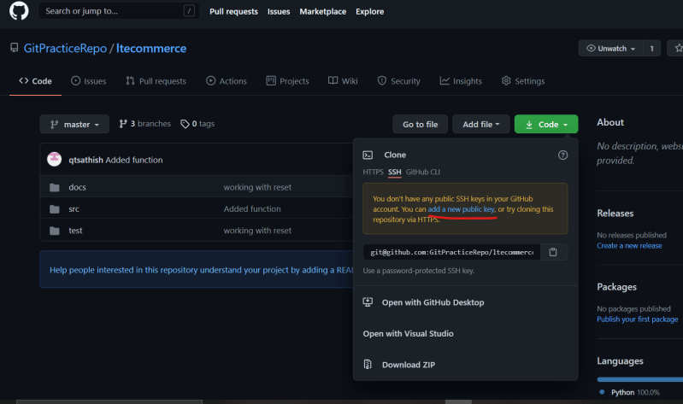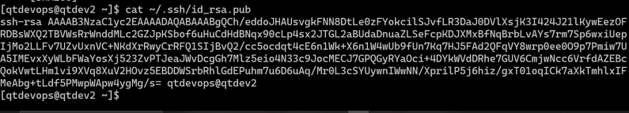

clone the repo on the linux machine for developer 2 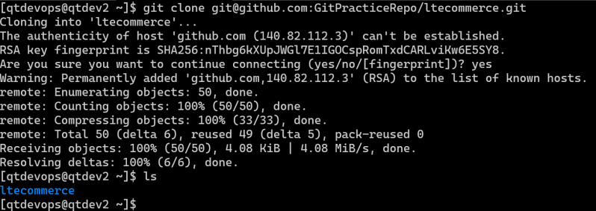

* Developer 1 starts working on a feature f1001 in the v1.0 branch
  + commit the changes of developer 1
* Developer 2 also starts working on feature f1002 in the v1.0 branch
  + commit the changes of developer 2
* As of now the state of branches after developers have done local changes 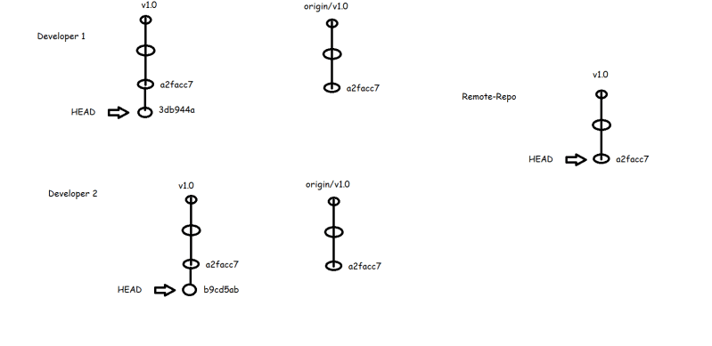
* Now Developer 2 has pushed the changes to the remote repository 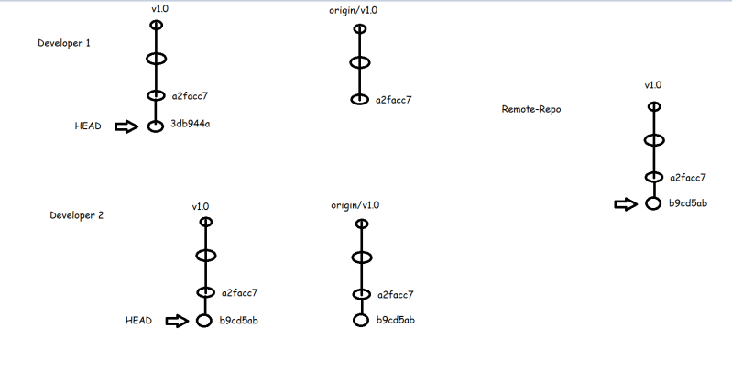
* In Git when we want to push the changes the remote-repository branch (which looks at latest commit) the origin/branch should exactly match with the remote repository branch
* Now Developer 1 wants to push the changes, this leads to error as origin/v1.0 is not matching the remote branch 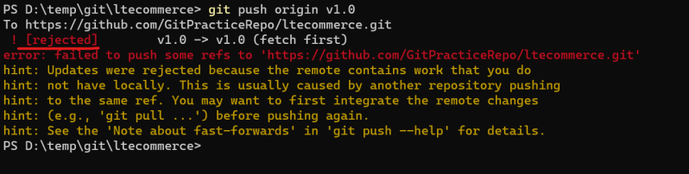
* Now Developer 1 updates the local repo by using pull command, fixes the merge 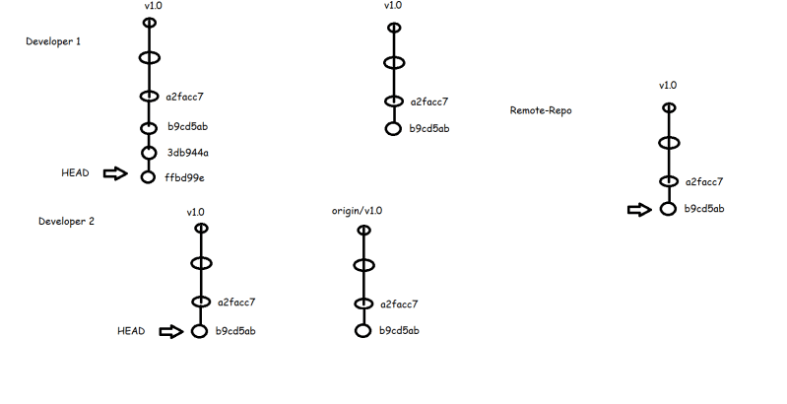
* Now Developer 1 can push his changes 
* Now Developer 2 starts working on feature f1003 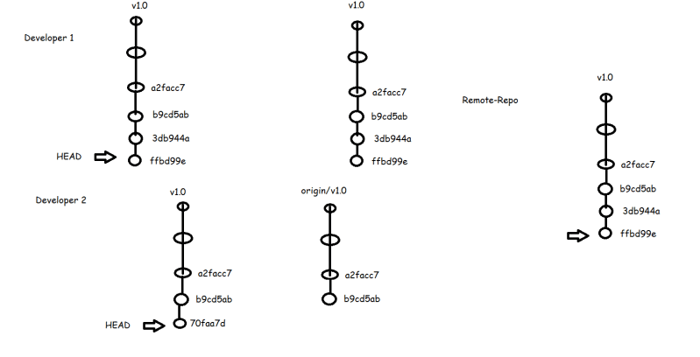
* When developer 2 pushes the changes, he will get error as he needs to pull the changes. Developer 2 wants to pull the changes, but he doesn’t want a new merge commit to be created.

git pull --rebase

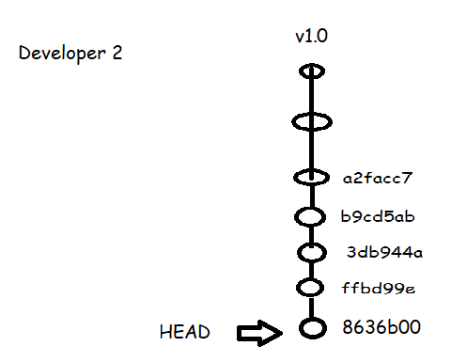

* Now both developer 1 can get the changes using git pull 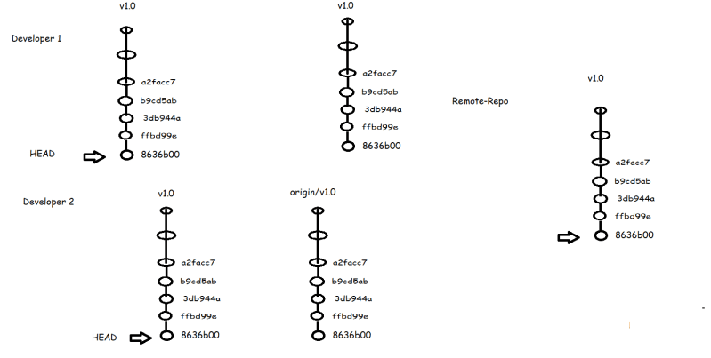

**Git Reset Hard vs mixed vs soft**

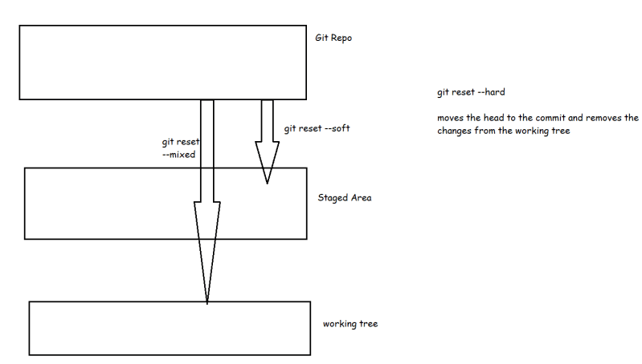

git pull = git fetch + git merge against tracking upstream branch

git pull --rebase = git fetch + git rebase against tracking upstream branch